# Assignment 2

## Commands

1. **Clear**
2. **Cd..**
3. **Ls**
4. **Cd**
5. **Mkdir**
6. **touch**

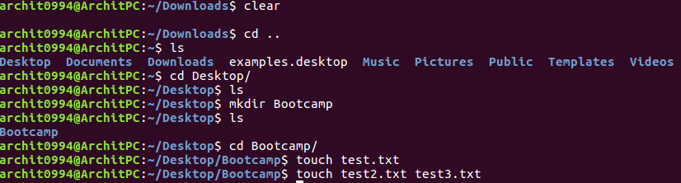

1. **Copy**
2. **Move**



1. **Man**
2. **Whoami**
3. **who**

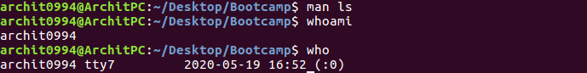

1. **Ping**
2. **Hostname**
3. **Ifconfig**

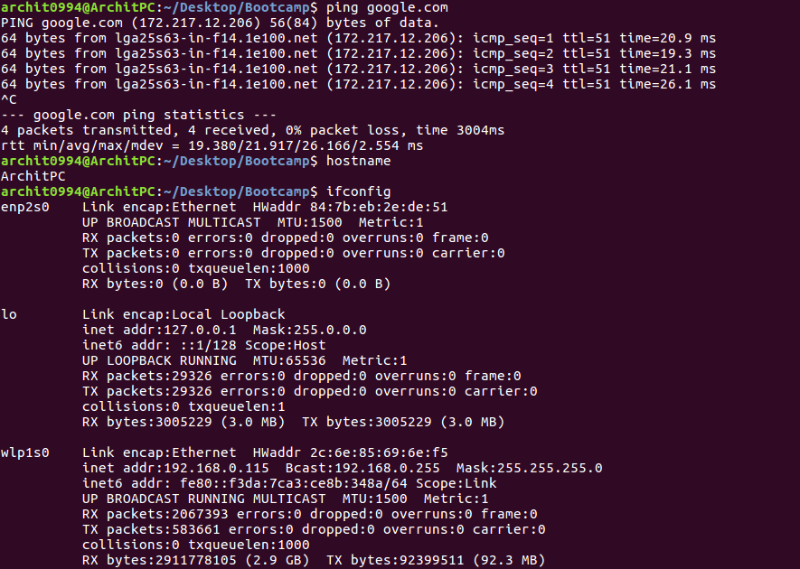

**15.History**

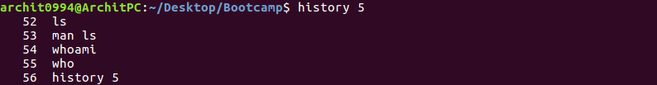

## Task 1

### Create directories which would have the following structure by using only mkdir command:



**mkdir -p consultadd/{Python/Django/restframework, java/springboot, javascript/{angular,react}, SQL/mysql,bootcamp}**

## Task 2

### Create Directory called consultadd



### Inside that create 5 more directories named them as dir1, dir2, dir3, dir4 and dir5

**mkdir dir1 dir2 dir3 dir4 dir5**



### What would be the output of Long Listing after creating these directories?



### List all the directories with ls and echo * and see the difference.

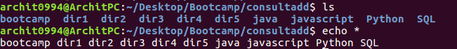

### Create a 2 files named them file1.txt and file2.txt inside dir3



### Move dir5 into the dir3

**mv dir5 dir3/**



* Remove dir 3 after moving all files from dir3 to dir2.

(How to copy just the content of dir 3?)

**cp -r dir3/ dir2/**





* Go to the dir2 and create one more file with name index.html

**Touch index.html**

* Move to top level directory

**Cd ~/**

* Check the permission of all files and directory from current place make sure when you do **pwd** it should be on consultadd



* Rename all files of dir2 with extension of .txt to .py

**rename 's/.txt/.py/' *.txt**



## Task 3

* What is Nano Editor?

Nano editor is an easy to use command line text editor for Unix and Linux operating systems. It includes all the basic functionality you’d expect from a regular text editor, like syntax highlighting, multiple buffers, search and replace with regular expression support, spellchecking, UTF-8 encoding

* + How to create a sample file in Nano Editor?
    - **nano sample.py**



* + How to save file?
    - **Ctrl+x**
    - **Y**
    - **Enter**
* What is Vi Editor?

Vi or the Visual Editor is the default text editor that comes with most Linux systems. It is a Terminal-based text editor  
**Reasons to use Vi include:**

* + Vi is available on almost all operating systems.
  + A smart range of shortcuts that comprise of short keystrokes.
  + You can use Vi as an excellent html editor.
  + The Vi commands are so rich that you hardly need to take your hands off the keyboard.
  + Vi editor creates small size files making it light on your storage.
  + Its free.
* **Operation in Vi Editor**

**Command Mode:** When vi starts up, it is in Command Mode. This mode is where vi interprets any characters we type as commands and thus does not display them in the window. This mode allows us to move through a file, and to delete, copy, or paste a piece of text.  
To enter into Command Mode from any other mode, it requires pressing the **[Esc]** key. If we press [Esc] when we are already in Command Mode, then vi will beep or flash the screen.

**Insert mode:** This mode enables you to insert text into the file. Everything that’s typed in this mode is interpreted as input and finally, it is put in the file. The vi always starts in command mode. To enter text, you must be in insert mode. To come in insert mode you simply type i. To get out of insert mode, press the Esc key, which will put you back into command mode.

**Last Line Mode(Escape Mode):** Line Mode is invoked by typing a colon [:], while vi is in Command Mode. The cursor will jump to the last line of the screen and vi will wait for a command. This mode enables you to perform tasks such as saving files, executing commands

## TASK 4

* Type **finger** to see your account and name.



* Type **cal** to see this month’s calendar.

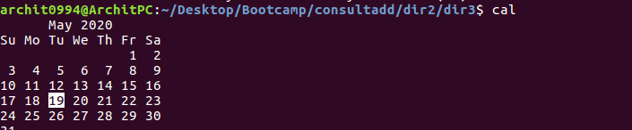

* Create a file and give a name random.txt to it with content into it which say “Hello Welcome to the Consultadd Inc Bootcamp”.

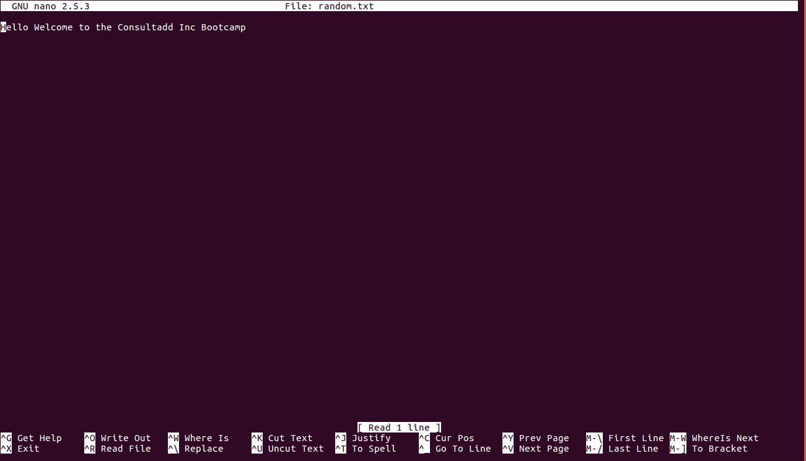

* Display the same content using **cat** command.



### 

## TASK 5

* Explain the workflow of the Internet in one paragraph

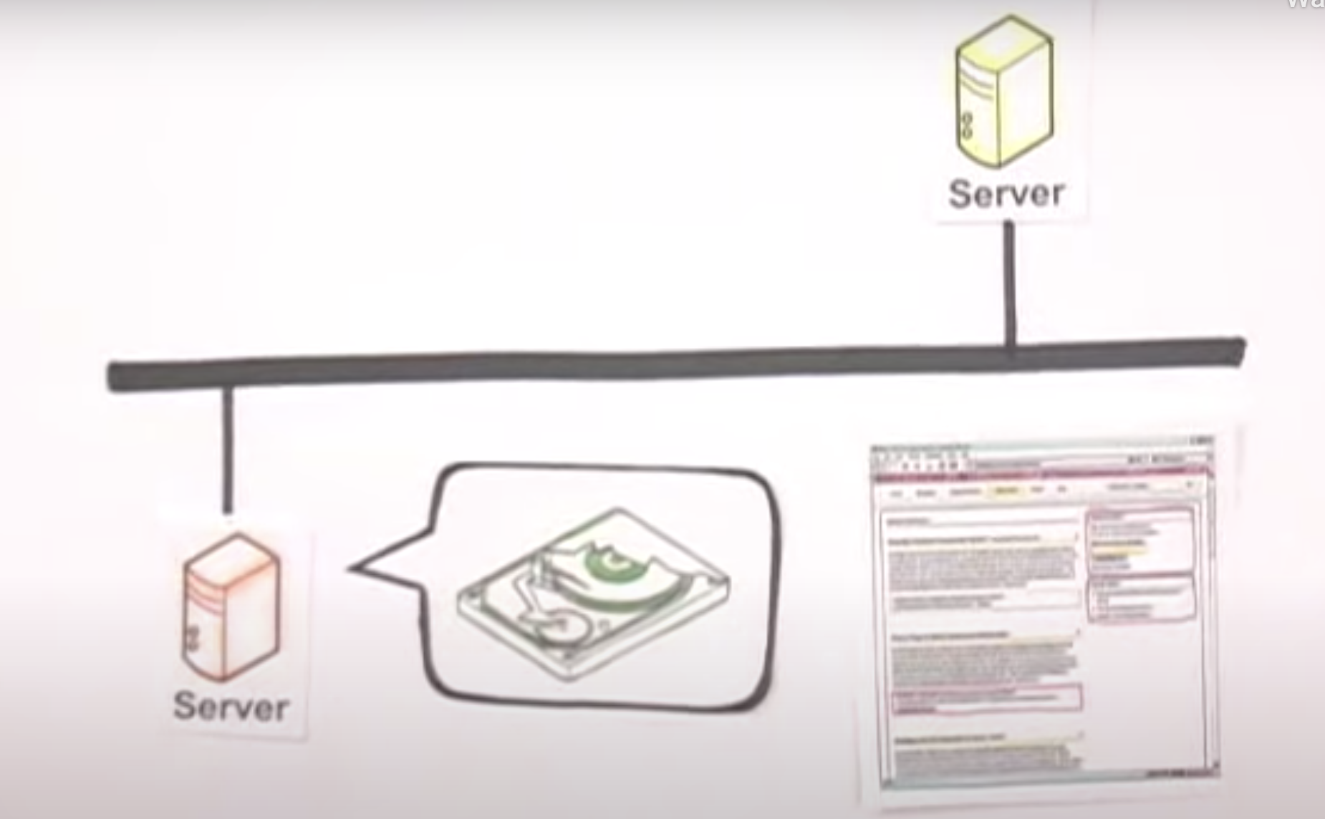

The internet transfers the information through packet switching. Each computer has unique IP address . The data is send over the internet from one device to another in the form of manageable packets. Each packet is assigned a port number that will connect it to its endpoint. A packet that has both a unique IP address and port number can be translated from alphabetic text into electronic signals by travelling through the layers of the OSI model from the top application layer to the bottom physical layer. The message will then be sent over the Internet where it is received by the Internet service provider's (ISP) router. The router will examine the destination address assigned to each packet and determine where to send it. Eventually, the packet reaches the client and travels in reverse from the bottom physical layer of the OSI model to the top application layer. During this process, the routing data -- the port number and IP address -- is stripped from the packet, thus allowing the data to be translated back into alphabetic text and completing the transmission process.

* How LAN is different from the WAN network?

|  |  |
| --- | --- |
| **LAN** | **WAN** |
| A LAN (local area network) is a group of computers and network devices connected together, usually within the same building. | A WAN (wide area network), in comparison to a MAN, is not restricted to a geographical location, although it might be confined within the bounds of a state or country. |
| the connections must be high speed and relatively inexpensive | The technology is high speed and relatively expensive |
| LAN is general confined to one building/complex | A WAN connects several LANs, and may be limited to an enterprise (a corporation or an organization) or accessible to the public. |

**GOOD WORK - Archit**

**But long listing command is ls -l**

**RIYAZ UL HAQUE**